Instructor Login to AIM for Testing
https://whitney.accessiblelearning.com/FSU/
- Access the instructor page by clicking the link above or copy and paste to your browser. You will be then be directed to enter your FSU user name and password though FSU – Central Authentication Services.
- You will be asked to acknowledge the school’s FERPA policy:
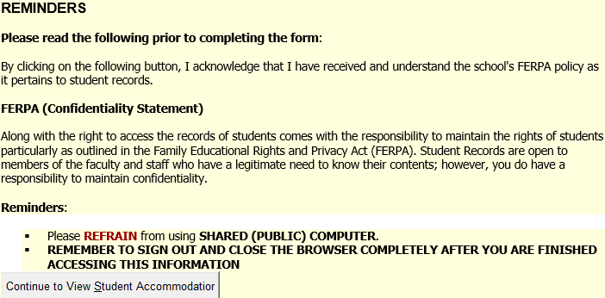
- Continue to View Student Accommodations. You will see the list of your students who have requested accommodations. Click on the view button on the left to see accommodations specific to each student.
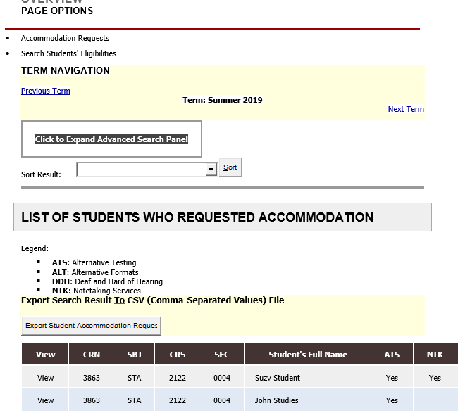
- On the left side of the screen, you will see views and tools. Please select Alternative Testing to complete the Testing Agreement. This will allow your student to schedule exams at the SDRC Exam Lab. It also provides our office with the information necessary to proctor exams on your behalf.
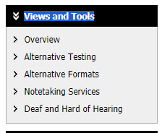

- The Alternative Testing Agreement will only need to be completed once per semester, per course and section. You can copy to other sections and courses as needed providing the exam rules are the same. You do not need to complete a Testing Agreement for each student.
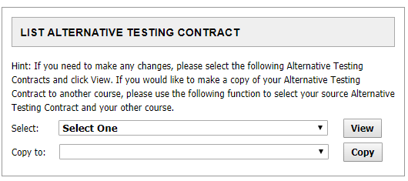
- The next few steps will be uploading the exam.
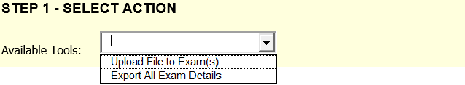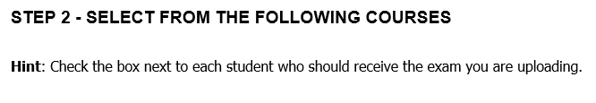
Questions?
Please contact our office if you have any questions or concerns regarding Alternative Testing request by emailing: oas-testing@fsu.edu

