How to log into AIM as an instructor
- Go to https://dsst.fsu.edu/oas/faculty
- Click on ‘Instructor Portal Login’
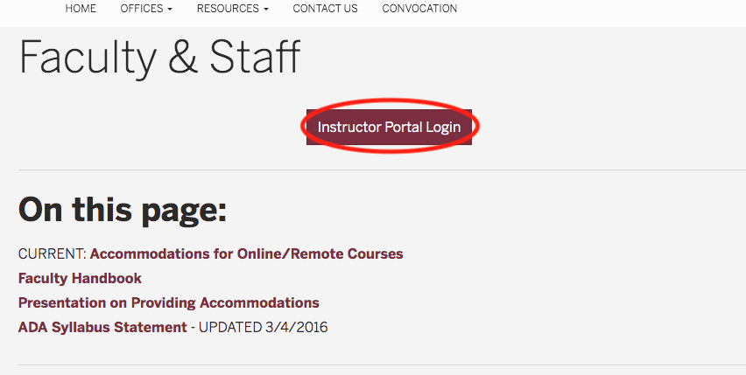
- Log in with your FSU ID and password
- Under the ‘INSTRUCTOR AUTHENTICATION PAGE,’ click on ‘Continue to View Student Accommodations’
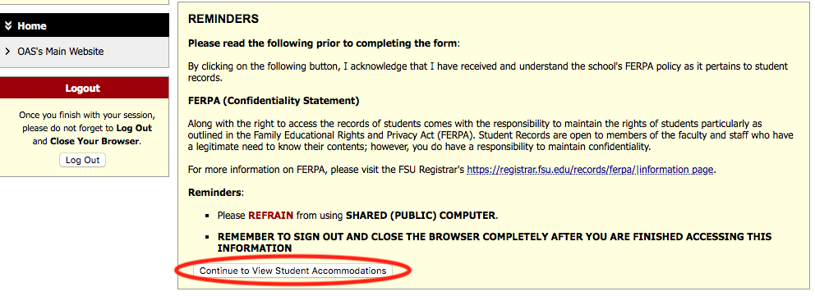
- You are in AIM when you see the ‘OVERVIEW’ page
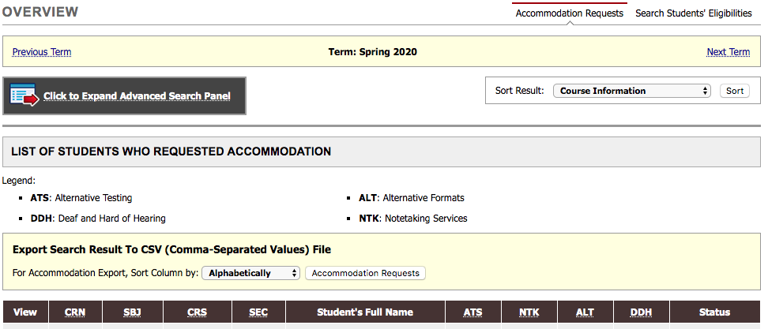
Questions?
Please contact our office if you have any questions or concerns by emailing: oas@fsu.edu

